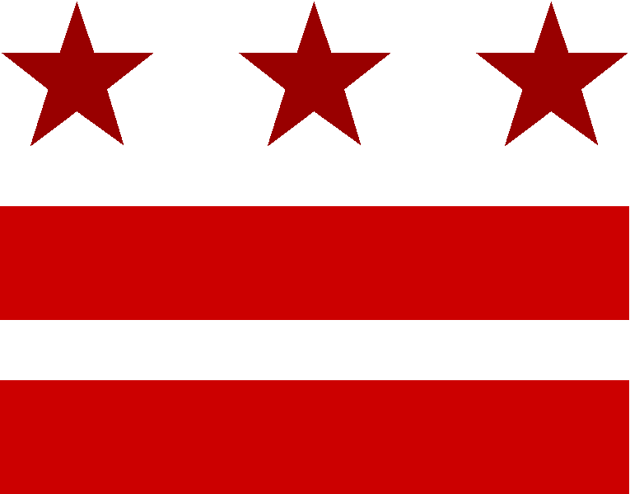
Advisory Neighborhood Commission 2A
“Serving the Foggy Bottom and West End communities of Washington, D.C.”

ANC 2A GRANT POLICIES AND PROCEDURES
\

Introduction
The Commission receives funds through “allotments” from the District Government. Under D.C. law, one allowable use of such funds is to provide grants to support community organizations and events, subject to certain guidelines and limitations. This grants procedure aims to normalize and standardize how and when the Commission provides grants.

Applicable Rules

The D.C. Code at Section 1-264, as amended by D.C. Law 13-135, authorizes Commissions to award grants to organizations for public purposes. The rules provided in the law are as follows:

- Grant requests must be made and awarded at a public meeting of the Commission.
- Grant awards shall provide a benefit that is public in nature and benefits persons who reside or work in the Commission area.
- Grant awards will not be made for non-public purposes or where services are provided for personal gain.
- Grant awards will not be made to an individual, because that is deemed a “non-public purpose” expenditure.
- Grant awards will not be made conditional on the applicant’s political support, or support of a position taken by the Commission.
- Grant awards will not be made to a District agency or program funded by the District Government.
- Grant awards will not be made if the funds will be used to purchase food or support activities that are primarily entertainment.
- Grant awards may not be requested retroactively for projects already completed.

In addition, the Commission includes the following rules and limitations on its grants:

- No applicant shall receive more than one grant in a given fiscal year.
- A grant request may not be made by a Commissioner.
- Commissioners who are board members of the organization requesting the grant may not vote on the grant request and may not participate in the review of the grant proposal.

Examples of allowable grant purposes include, but are not limited to, the following:

- A grant to a civic organization to further a neighborhood beautification project; or
- A grant to a parent-teacher association to fund such activities as computer literacy programs, musical instruction programs, or local cultural education field trips.

Examples of unallowable grant purposes include, but are not limited to, the following:

- A grant to a community organization for food for an annual picnic; or
- A grant to an individual to create a neighborhood art project.

Procedures for Dispensing Grant Funds

The Commission must be very careful in how grant payments are made. Commissions around the city have historically had problems with follow-up reporting and receipts from grantees, which can lead investigations from the D.C. Auditor’s office and consequent decreases in the relevant Commission’s allotment. Therefore, the Commission will only pay grant project funds in one of two ways:

- The grantee will provide an invoice to the Treasurer from the applicable vendor, and the Commission will pay that vendor directly for the goods or services. In this method, no money goes from the Commission to the grantee directly, and the Commission receives the “paid” receipt directly from the vendor.

- The grantee will provide the Treasurer a receipt for services or goods paid, and the Commission will then reimburse the grantee for that amount. Absolutely no funds will be issued directly to a grantee unless and until the grantee first provides the Treasurer a receipt or invoice from the vendor.

Criteria for Judging Grant Applications

Grant applications will be judged based on the following criteria:

- Does the proposed grant project comply with the rules applicable under D.C. law and this policy?
- Does the grant project benefit those who live and work in the Foggy Bottom and West End neighborhoods?
- Does the applicant provide clear goals for the grant project?
- Does the applicant provide ways of measuring the outcome or benefits of the grant project?
- Does the applicant provide a clear budget for the grant project?
- Does the grant application describe with particularity which cost items will be paid with the Commission’s grant funds?
- Does the applicant demonstrate need for grant funds from the Commission?
- Has the applicant diligently sought funds from other sources for the grant project?
- Will the grantee use D.C. area vendors and services to implement the grant project?

Procedures for Grant Applications

- Amount of Funds Available for Grants

The Commission shall determine whether and how much funding is available for grants in a given fiscal year. This determination should be made during the initial approval of the Commission’s annual budget.

As of currently:

- The Commission has allocated $2,000 in grant funding for FY 2015.
- The Commission has stated that $1,000 of this grant funding will be allocated for each of the two rounds of grant applications (explained below).
- The Commission has stated that no individual grant request can exceed $1,000.
- Any remaining funds from a given grant round will roll over into the next grant round as long as both rounds are in the same fiscal year.

- Request for Proposals

Once the Commission approves a total amount available for grant funding for the fiscal year, the Commission shall release public notice of available grant funding and a request for grant applications.

- Timing of Grant Applications

Unless the Commission votes otherwise, grant applications will be considered twice a year in accordance with the following schedule:

FIRST ROUND:

- September 1st – Grant applications due
- September and early October – Commissioners read through the grant application and prepare questions and arguments for or against approval of the grant
- October public ANC Meeting – Commission hears from the applicant(s), debates the merits of the grant application and the proposed grant’s benefits, and votes on final grant approval
- December 1st – Grantee report due

SECOND ROUND:

- March 1st – Grant applications due
- March and early April – Commissioners read through the grant application and prepare questions and arguments for or against approval of the grant
- April public ANC Meeting – Commission hears from the applicant(s), debates the merits of the grant application and the proposed grant’s benefits, and votes on final grant approval
- June 1st – Grantee report due

- Information Required of Grant Applicants

- A written grants application to the Commission describing the proposed project, using the standard ANC 2A grant form.
- A statement of grant project goals that includes a description of what the organization hopes to accomplish. (Goals tend to be broad, general, intangible, and abstract. A goal is really about the final impact or outcome.)
- A statement of the grant project objective(s) with verifiable steps toward accomplishing the goal. (In contrast to the goals, objectives are narrow, precise, tangible, concrete, and can be measured.)
- A statement indicating if funding for this project is available to the applicant from other sources, and what efforts the applicant has made to secure funding from other sources.
- A project budget – including other sources of funding, where applicable, and a description of which cost items are to be funded by the Commission’s grant.
- An explanation that shows that the services/benefits proposed do not duplicate those that are already performed by the District Government.
- An explanation of whether the applicant plans to use District of Columbia vendors and services to implement the grant.
- Full information about the applicant – including organization name, address, contact information, annual organizational budget, any IRS status documentation, and a certificate of good standing from the District of Columbia.
- A statement that the applicant has reviewed this policy and the applicable D.C. law and believes that the application comports with all requirements.
Applicants should be aware that non-responsive applications or applications with missing information or documentation may not be considered.

- Submission of Grant Materials

All of the details for the ANC 2A Grant Fund will be provided on an individual page of the ANC website (www.anc2a.org). This will include the grant allocation schedule, the downloadable grant application, and a list of additional required materials.

Once an applicant has completed the grant application, the application and all other required materials will either be emailed to the ANC 2A Grant Fund email address (DCANC2A@gmail.com) or mailed to the Commission’s PO box. The preferred method of submission will be via email. The Chair will pick up the submitted application, and will in turn promptly distribute the application to all of the Commissioners for review.

- Official Approval of Applications
Only the full Commission has authority to approve grants or any other expenditure of funds. The D.C. law also requires that grant requests be made and awarded at a public meeting of the Commission.

The Commission will hear from the applicant(s), debate the merits of the grant application and the proposed grant’s benefits to the Foggy Bottom and West End communities, and vote on final approval of the grant application, all at a public meeting following the above grant schedule.

- Notice of Award of Grant
The Commission, acting through the Chair and Treasurer, shall notify approved grantees in writing, including next steps and instructions. Grantees shall acknowledge this letter and the grant requirements by signing the letter and returning it to the Commission.

- Payment of Grant Funds
Payment of grant funds shall take place after the Treasurer receives the invoice or receipt as described above. All checks issued to the billing company or to the applicant based on a receipt a payment will be signed by the Treasurer and another executive board member.

- Grantee Report
As described in the D.C. law, the grantee shall generate a final report on the Commission’s grant funds and submit it to the Commission within 60 days after approval of the grant, or in accordance with the timelines described above, whichever is shorter.

- Relinquishment of Grant

If the grantee does not provide an invoice to be paid from a vendor, or a receipt for reimbursement, within 60 days of the award of the grant, the grantee relinquishes the grant.

- Breach of Grant

If the grantee is determined to be in breach of the grant requirements and conditions, the Commission shall notify the grantee by certified mail and may report the grantee to the D.C. Auditor and/or the Office of the Attorney General. Any grantee found in breach of a grant shall be ineligible to receive a grant from the Commission for the remainder of that fiscal year, as well as the subsequent fiscal year.

- These policies and procedures were approved by the full ANC at ANC 2A’s
regular meeting on June 18, 2014.

